Furniture

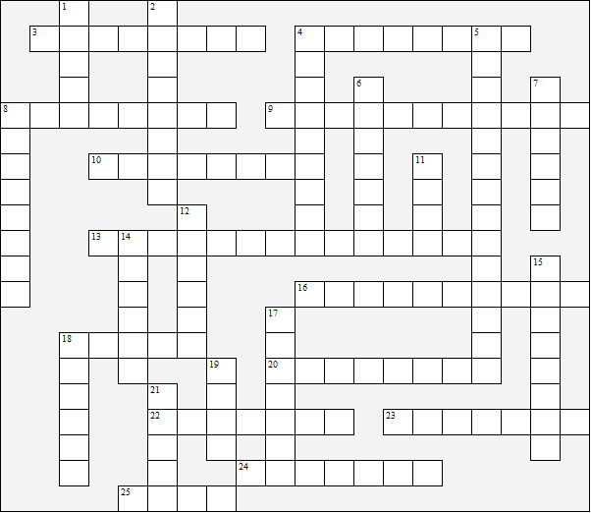

Across:  3 bookcase  4 bed-settee  8 sideboard  9 rug  10 blind  13 coffee table  16 desk  18 drawer  20 stool | 22 wardrobe  23 dressing table  24 shelf  25 sofa  Down:  1 chair  2 rocking chair  4 high-chair  5 bedside table | 6 curtain  7 cupboard  8 carpet  11 cot  12 armchair  14 mirror  15 net curtains  17 bunk beds  18 chest of drawers  19 bed  21 bench
Furniture – Solution

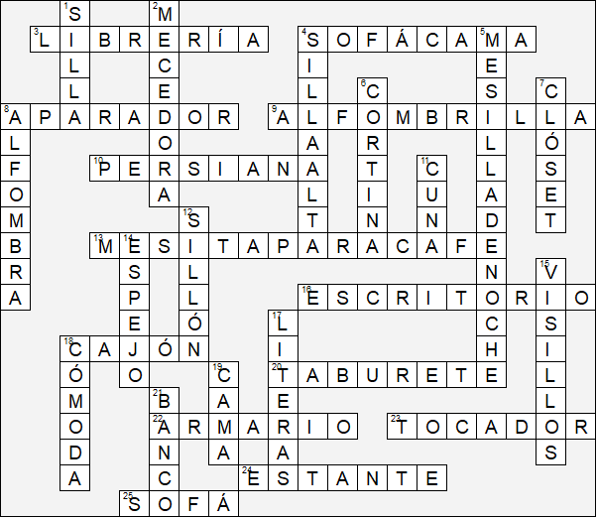

Esta hoja de trabajo se realizó utilizando TOOLBOX por Discovery Educational Software.

