The garden

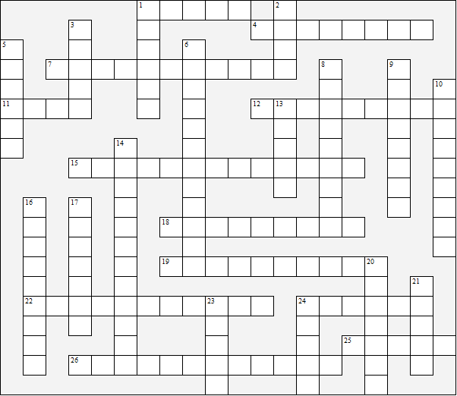

Across:  1 fork  4 watering can  7 greenhouse  11 spade  12 rake  15 decking  18 sunshade  19 wheelbarrow  22 lawnmower  24 gate  25 sieve | 26 fertiliser  Down:  1 vegetable patch  2 hedge  3 hose  5 lawn  6 rockery  8 manure  9 swing | 10 shed  13 hoe  14 trowel  16 weed-killer  17 path  20 flowerbed  21 wall  23 patio  24 gatepost
The garden – Solution

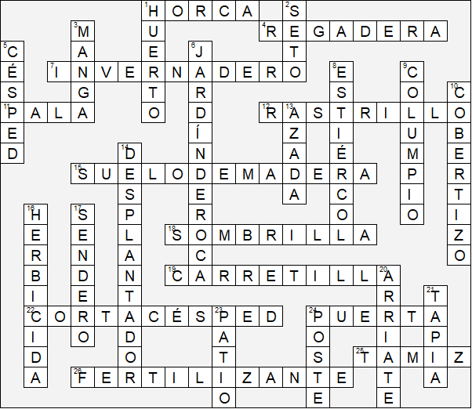

Esta hoja de trabajo se realizó utilizando TOOLBOX por Discovery Educational Software.

