Les Français célèbres

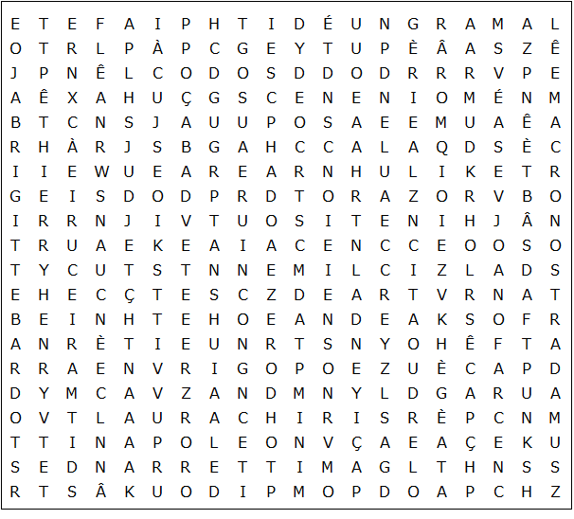

Marie Antoinette Charles de Gaulle Guy de Maupassant

Charles Aznavour Brigitte Bardot Zinedine Zidane Chirac

Alain Prost Thierry Henry Proust David Guetta

Eric Cantona Marie Curie Mitterrand Victor Hugo

Depardieu Descartes Édith Piaf Nostradamus Coco Chanel

Hollande Maurice Chevalier Sarkozy Macron Monet

Joan of Arc Daft Punk Napoleon Pompidou Debussy

Qui sont ces personnes célèbres? Who are these famous people?
Les Français célèbres - Solution

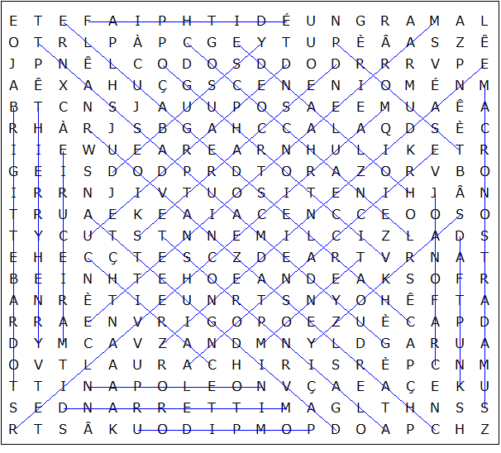

Ce puzzle a été créé en quelques secondes à l'aide de Toolbox, disponible pour seulement 20 £ sur discoveryeducationalsoftware.co.uk

Les Français célèbres - Who they are

Alain Prost: four times Formula One World Drivers' Champion
Brigitte Bardot: film star and singer
Charles Aznavour: singer 1924-2018
Charles de Gaulle: president 1959-1969
Chirac, Jacques: president 1995-2007
Coco Chanel: perfumier and fashion designer
Daft Punk: electronic music duo
David Guetta: DJ and record producer
Debussy, Claude: 19th-20th century composer
Depardieu, Gérard: actor and film star
Descartes, René: 16th-17th century mathematician and philosopher
Édith Piaf: singer 1915-1963
Eric Cantona: footballer (inc. Manchester Utd.) and actor
Guy de Maupassant: 19th century author
Hollande , François: president 2012-2017
Joan of Arc: 15th century national heroine of France
Macron, Emmanuel: president 2017-
Marie Antoinette: 18th century wife of Louis XVI, guillotined in the French Revolution
Marie Curie: 19th-20th physicist and chemist
Maurice Chevalier: singer and actor 1888-1972
Mitterrand, François: president 1981-1995
Monet, Claude: 19th-20th century impressionist painter
Napoleon Bonaparte: emperor 1804-1814
Nostradamus: 16th century astrologer, apothecary and physician
Pompidou, Georges: president 1969-1974
Proust, Marcel: 19th-20th century novelist
Sarkozy, Nicolas: president 2007-2012
Thierry Henry: footballer (inc. Arsenal) and coach
Victor Hugo: 19th century author of The Hunchback of Notre Dame and Les Misérables
Zinedine Zidane: footballer (inc. Real Madrid) and manager

