French numbers maze

Start at the top left corner. Moving right, left, up or down, draw a line as you find the French numbers to 49: un, deux, etc.

You should finish at **

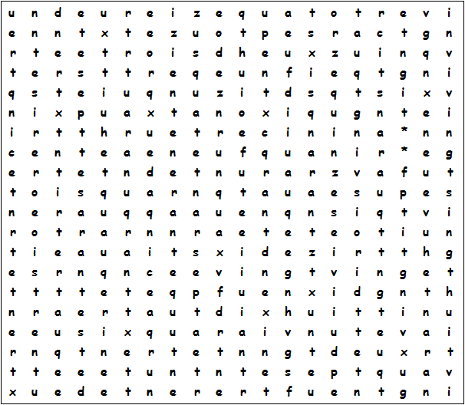

French numbers maze - Solution

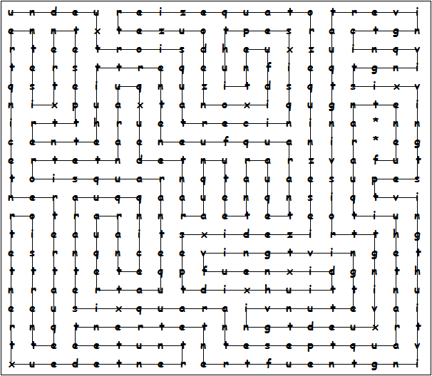

This puzzle was compiled in seconds using Toolbox.
For a free trial go to www.discoveryeducationalsoftware.co.uk

