Le zoo

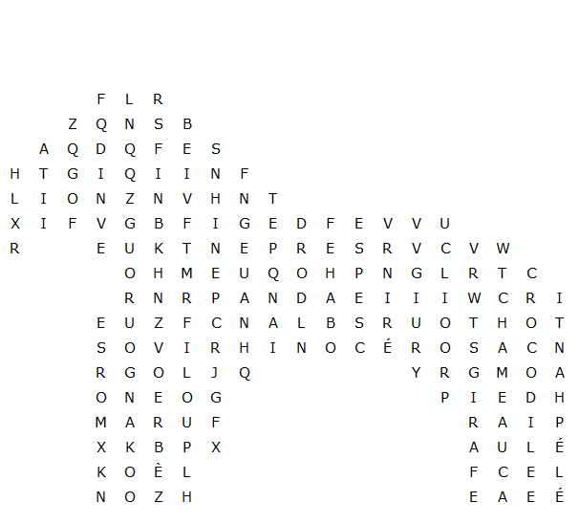

rhinocéros crocodile kangourou oursblanc panda

éléphant chameau renne morse lion loup

serpent girafe phoque tigre zèbre singe

Le zoo – Solution
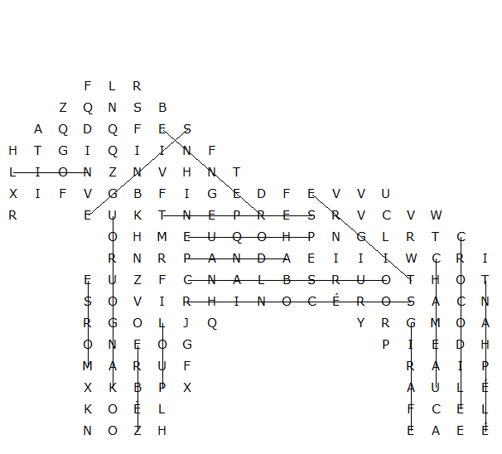

This puzzle was created in seconds using Toolbox, available for only £10 from discoveryeducationalsoftware.co.uk

