Nineteen Eighty-four
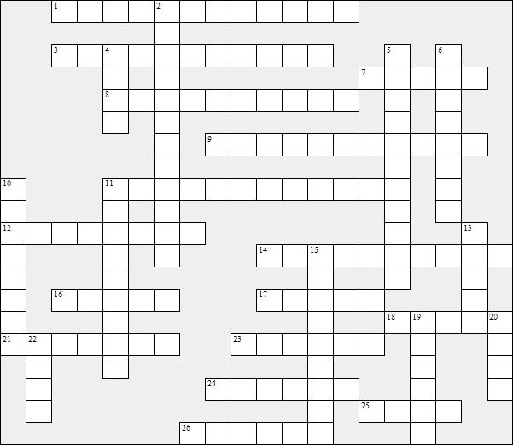
Across:  1 The cafe (2 words)  3 The new name for Great Britain (2 words)  7 The Ministry of ... concerns itself with lies  8 The device that watches, listens and  transmits  9 Having two contadictory beliefs at the  same time  11 The instrument that composes songs  12 The language that will replace English  14 Finally Winston says he loves ........ (two  words)  16 Winston's surname  17 The girl Winston forms a relation with  18 The young people's organisation: The .....  21 The slogan: Freedom is ........  23 The philosophy of Oceania  24 Ordinary people, non party members | 25 Every day there is a Two Minutes .....  26 The person who tortures Winston  Down:  2 The kind of government in Oceania  4 Animals used for torture in Romm 101  5 The resistance group: The .......  6 The slogan: Ignorance is .......  10 Winston lives in Victory ........  11 People that disappear are said to be .......  13 The Ministry of ….. concerns itself with  war  15 The leader of the resistance group  19 The Ministry of ..... concerns itself with  starvation  20 The person working on the dictionary  22 The Ministry of ...... concerns itself with  torture
Nineteen Eighty-four – Solution

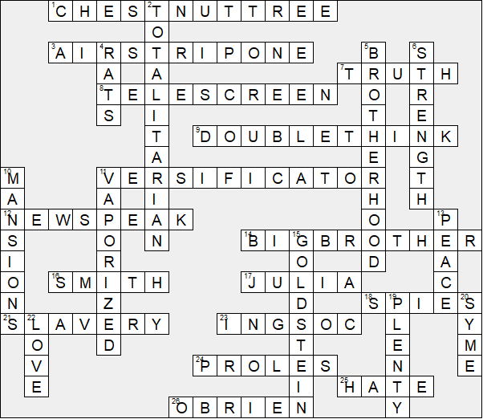

This worksheet was made up using TOOLBOX by Discovery Educational Software.

