50 Animals Wordsearch

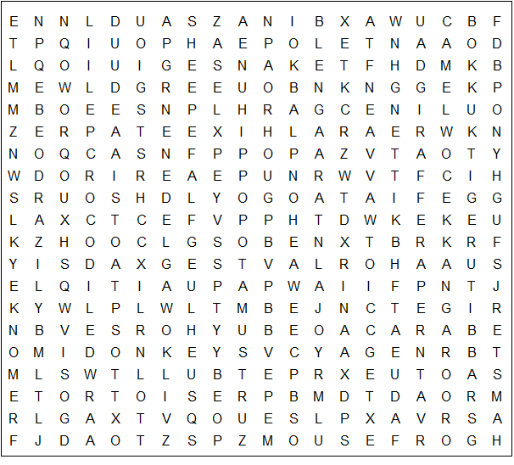

cow fox rat ape pig tortoise antelope cat

hippopotamus rhinoceros crocodile elephant penguin

kangaroo antelope leopard giraffe pelican hamster

jaguar monkey walrus kitten donkey badger rabbit

weasel spider lizard horse sheep tiger zebra

camel puppy panda mouse stoat lion wolf bear

goat deer seal toad pony frog bull dog snake
50 Animals Wordsearch – Answer Sheet

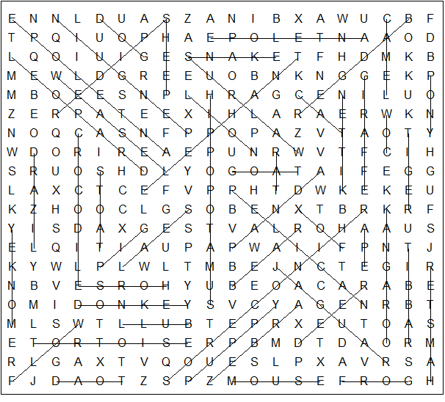

This puzzle weas created in seconds using Toolbox, available for only £10 from discoveryeducationalsoftware.co.uk

