Animal Farm
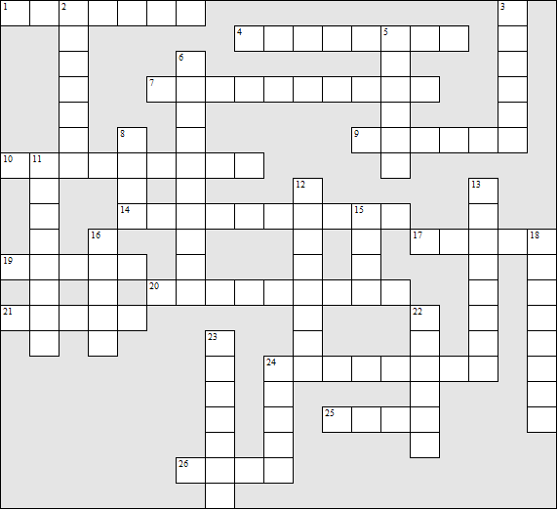
Across:  1 The Battle of the …........ (the first battle)  4 The donkey  7 Mr. Frederick's farm  9 A pile of ........ was sold to a neighbouring  farm  10 The banknotes paid by Mr Frederick  were ...........  14 ............ Mountain, the animals' 'heaven'  17 The farmer  19 ......... Farm, it's original name  20 The name the animals gave to their  system  21 The strongest horse  24 The pig that is expelled from the farm  25 Muriel is a ..........  26 On the flag were a hoof and a ......... | Down:  2 Mr. ..........., the intermediary  3 The mare who survived to the end of the  story  5 The pretty horse who defected  6 The nearby town  8 “Four ..... good, two ...... bad”  11 The original prize white boar (2 words)  12 The pig that becomes leader  13 The Battle of the ....... (the second battle)  15 Napoleon has huge ....... as bodyguards  16 The raven  18 The pig who relays Napoleon's  instructions to the other animals  22 “.......... of England”, the anthem  23 Mr. Pilkington's farm  24 The number of commandments written  on the barn wall
Animal Farm – Solution

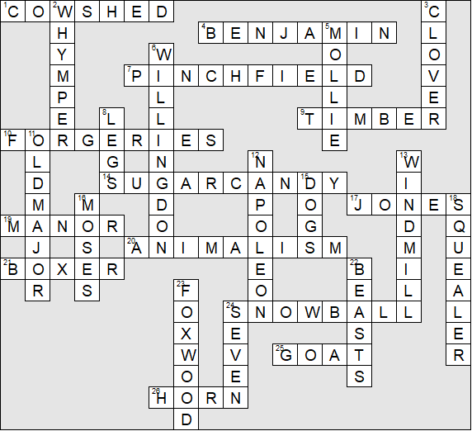

This worksheet was made up using TOOLBOX by Discovery Educational Software.

