ANIMALS

Try to fit the animals into the puzzle.

Start with the longest word.

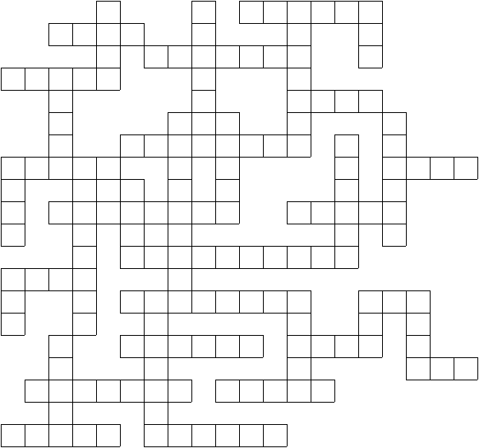

dog horse cat cow sheep lion tiger elephant zebra

wolf fox tortoise bear snake rhinoceros antelope jaguar

leopard camel giraffe hippo monkey goat deer crocodile

seal walrus kangaroo toad rat pony kitten puppy donkey

pelican panda frog hamster mouse
ANIMALS - Solution

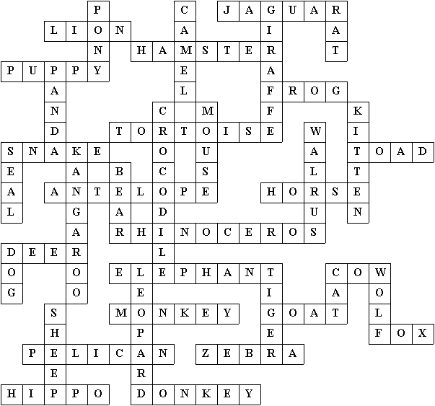

This puzzle was compiled in seconds using Toolbox.
For a free trial go to www.discoveryeducationalsoftware.co.uk

