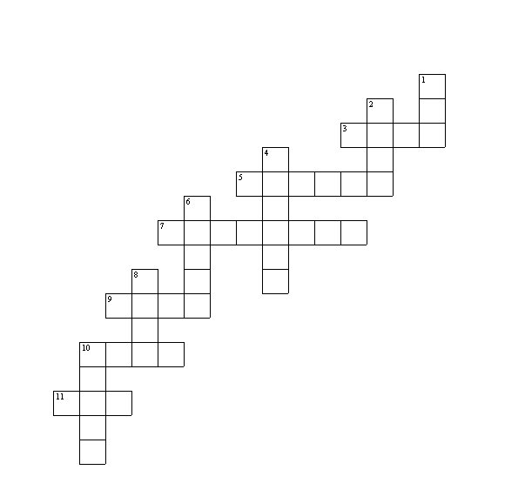
Baby Animals

Across:  3 sheep  5 cat  7 duck  9 kangaroo  10 cow  11 goat | Down:  1 lion  2 deer  4 pig  6 dog  8 horse  10 bird

Baby Animals (solution)

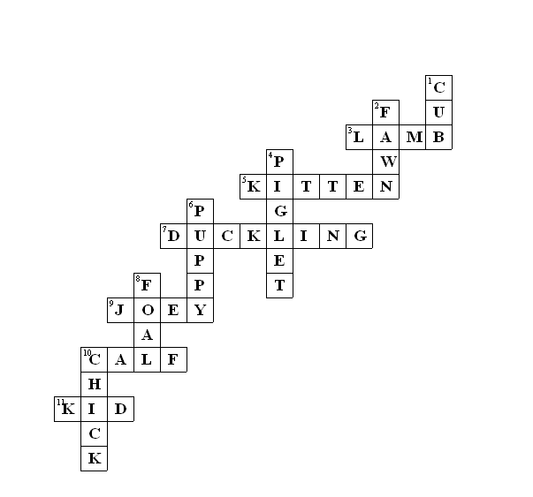

This puzzle was compiled in seconds using Toolbox.
For a free trial go to www.discoveryeducationalsoftware.co.uk/toolbox_e.htm

