The Beatles Number Ones

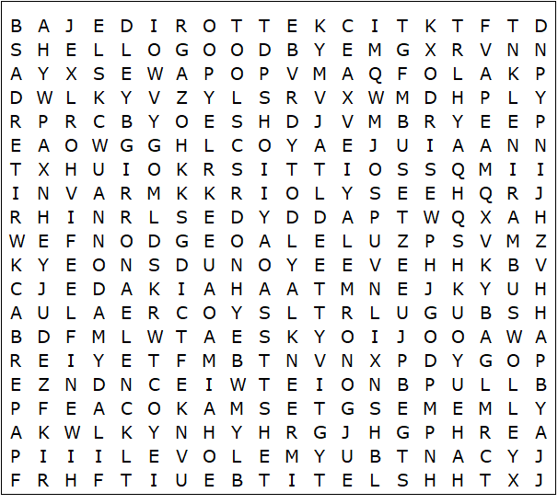

A Hard Day's Night  All You Need Is Love  Can't Buy Me Love  Day Tripper  Eleanor Rigby  From Me To You  Get Back  Hello Goodbye  Help  Hey Jude | I Feel Fine  I Want To Hold Your Hand  Lady Madonna  Let It Be  Paperback Writer  Penny Lane  Please Please Me  She Loves You  Ticket To Ride  Yellow Submarine

The Beatles Number Ones – Solution

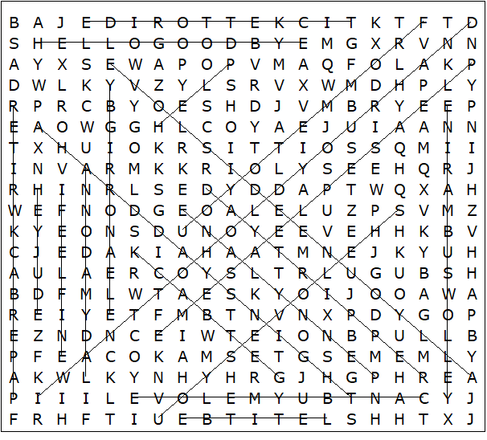

This worksheet was made up using TOOLBOX by Discovery Educational Software.

