Leonard Bernstein

This text has been coded using numbers instead of letters.

1 = A, 2 = B, 3 = C etc.

Using the grid below will help you crack the code.

12 5 15 14 1 18 4 2 5 18 14 19 20 5 9 14 23 1 19 8 9 7 8 12 25 18 5 7 1 18 4 5 4 1 19 1 4 9 18 5 3 20 15 18, 3 15 13 16 15 19 5 18 1 14 4 16 9 1 14 9 19 20.

8 5 9 19 16 18 15 2 1 2 12 25 2 5 19 20 11 14 15 23 14 6 15 18 23 18 9 20 9 14 7 20 8 5 13 21 19 9 3 6 15 18 20 8 5 13 21 19 9 3 1 12 23 5 19 20 19 9 4 5 19 20 15 18 25.

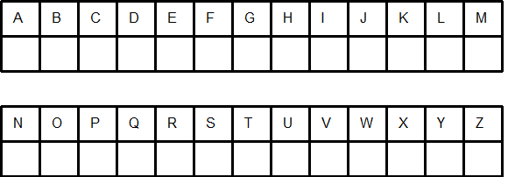
Leonard Bernstein (Solution)

Leonard Bernstein was highly regarded as a director, composer and pianist.

He is probably best known for writing the music for the musical West Side Story.

This worksheet was made up using TOOLBOX by Discovery Educational Software.

