Birds

Beginning with the letter in the square box, follow a continuous path to find the words listed below. The trail passes through each and every letter once and may twist up, down or sideways, but never diagonally.

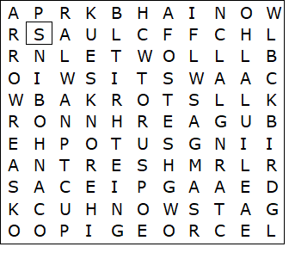

BLACKBIRD  BLUE TIT  CHAFFINCH  CROW  CUCKOO  EAGLE  HERON  LARK  MAGPIE  OWL | PHEASANT  PIGEON  ROBIN  SEAGULL  SPARROW  STARLING  STORK  SWALLOW  SWAN  THRUSH

Birds - Solution

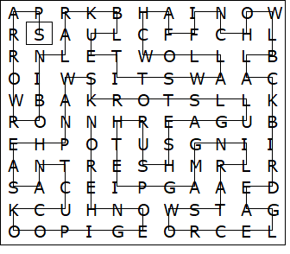

This worksheet was made up using TOOLBOX by Discovery Educational Software.

