20 Common Birds

1  2  3  4  5  6  7  8  9  10  11  12  13  14  15  16  17  18  19  20 |                                        | ……………………..  ……………………..  ……………………..  ……………………..  ……………………..  ……………………..  ……………………..  ……………………..  ……………………..  ……………………..  ……………………..  ……………………..  ……………………..  ……………………..  ……………………..  ……………………..  ……………………..  ……………………..  ……………………..  ……………………..

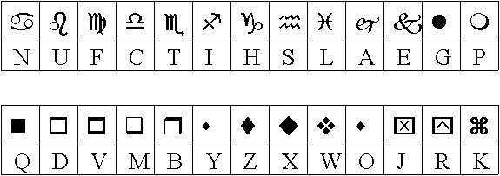
20 Common Birds - Solution:

- blackbird  - thrush  - seagull  - robin  - eagle  - hawk  - swallow  - wren  - sparrow  - kingfisher | - yellow hammer  - vulture  - owl  - starling  - albatros  - crow  - magpie  - blue tit  - lark  - swan

This puzzle was compiled in seconds using Toolbox.
For a free trial go to www.discoveryeducationalsoftware.co.uk/toolbox_e.htm

