Parts of the body

Beginning with the letter in the square box, follow a continuous path to find the words listed below. The trail passes through each and every letter once and may twist up, down or sideways, but never diagonally.

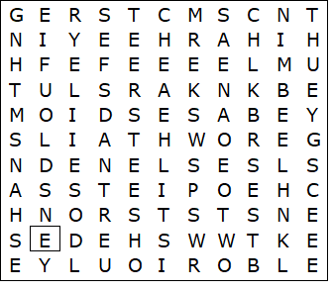

ANKLE  ARMS  CHEEKS  CHEST  CHIN  EARS  ELBOW  EYEBROWS  EYELIDS  EYES  FEET  FINGERS | HANDS  KNEE  LEGS  LIPS  MOUTH  NAILS  NOSE  SHOULDER  TEETH  THUMB  TOES  WRIST

Parts of the body – Solution

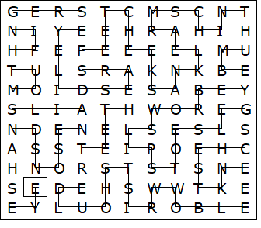

This worksheet was made up using TOOLBOX by Discovery Educational Software.

