James Bond films

Beginning with the letter in the square box, follow a continuous path to find the words listed below. The trail passes through each and every letter once and may twist up, down or sideways, but never diagonally.

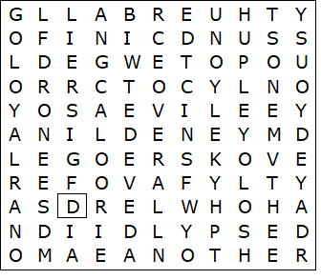

CASINO ROYALE  DIAMONDS ARE FOREVER  DIE ANOTHER DAY  GOLDEN EYE  GOLDFINGER | OCTOPUSSY  SKYFALL  THE SPY WHO LOVED ME  THUNDERBALL  YOU ONLY LIVE TWICE

James Bond films – Solution

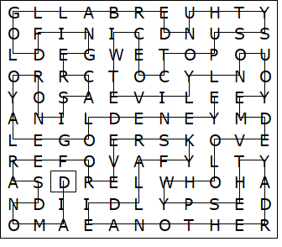

This worksheet was made up using TOOLBOX by Discovery Educational Software.

