James Bond films

Find twenty James Bond films hidden in this puzzle.

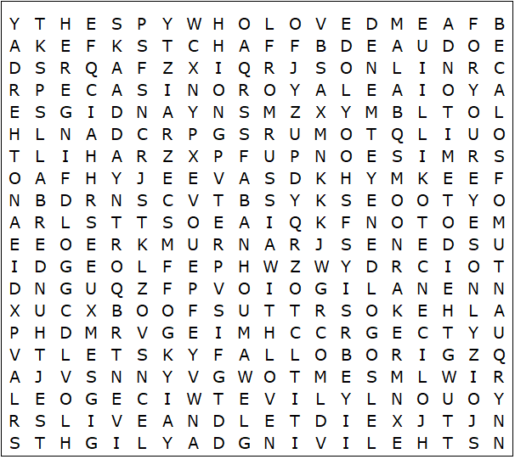

James Bond films – Solution

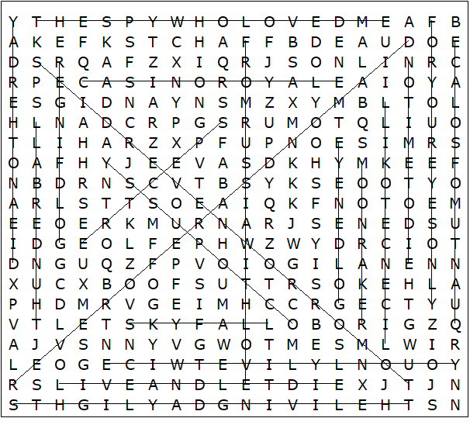

Casino Royale  Diamonds are forever  Die another day  For your eyes only  From Russia with love  Goldeneye  Goldfinger  Licence to kill  Live and let die  Moonraker | No time to die  Octopussy  Quantum of solace  Skyfall  Spectre  The living daylights  The spy who loved me  Thunderball  Tomorrow never dies  You only live twice

This worksheet was made up using TOOLBOX by Discovery Educational Software.

