Boy and Girl Bands

1 Find the 22 boy bands, girl bands and boy-girl bands hidden in the puzzle

2 Going from left to right, starting with the top row, write down all the letters which have not been used, to find four more bands.

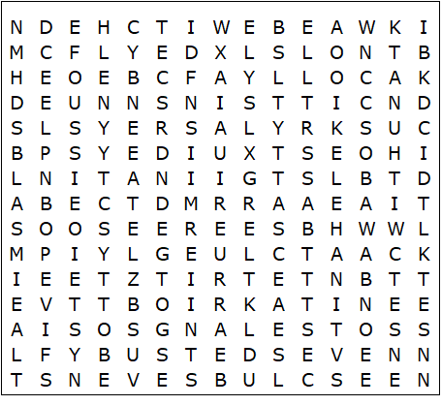

All Saints  Backstreet Boys  Bewitched  Blue  Boyzone  Busted | Eternal  Five  Girls Aloud  Little Mix  McFly  N Sync | One Direction  S Club Seven  Saturdays  Spice Girls  Steps  Liberty X | Sugababes  Take That  Wanted  Westlife

Boy and Girl Bands – Solution

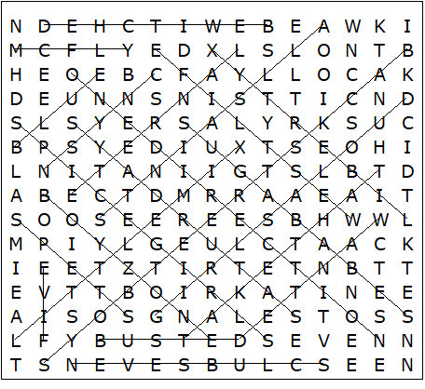

The additional bands are:

New Kids on the Block
Destinys Child
East Seventeen
Atomic Kitten

This worksheet was made up using TOOLBOX by Discovery Educational Software.

