The Bristol Balloon Fiesta

There are two versions of this worksheet.

The first requires the student to work out what the text says.

The second gives the student the text.

The Bristol Balloon Fiesta

Starting at the top left-hand corner, follow a continuous path to read about the Bristol Balloon Fiesta. The path goes left, right, up and down, but not diagonally. Each letter is used only once.

Write it out correctly, putting in spaces and punctuation.

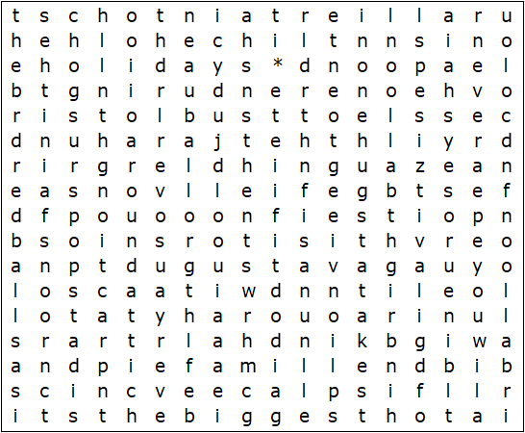

The Bristol Balloon Fiesta

Starting at the top left-hand corner, follow a continuous path to find the following text. The path goes left, right, up and down, but not diagonally. Each letter is used only once.

The Bristol Balloon Fiesta takes place every August, and with around half a million visitors, over a hundred balloons, fairground attractions, pop stars and picnics, it's the biggest hot air balloon festival in Europe. You will find big, bright balloons in every shape, size and colour, all in one huge field - just the thing to entertain the children during the school holidays.

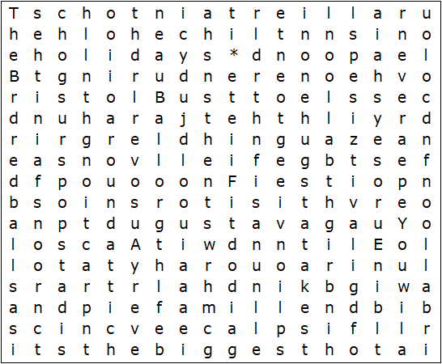
The Bristol Balloon Fiesta – Solution

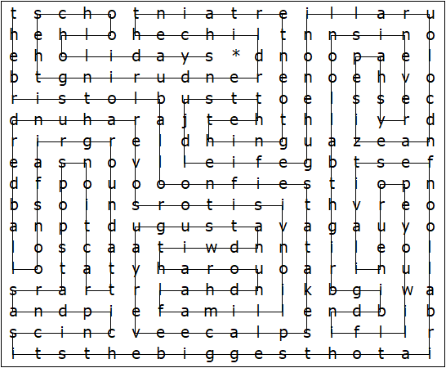

The Bristol Balloon Fiesta takes place every August, and with around half a million visitors, over a hundred balloons, fairground attractions, pop stars and picnics, it's the biggest hot air balloon festival in Europe. You will find big, bright balloons in every shape, size and colour, all in one huge field - just the thing to entertain the children during the school holidays.

This worksheet was made up using TOOLBOX by Discovery Educational Software.

