Brother in the Land

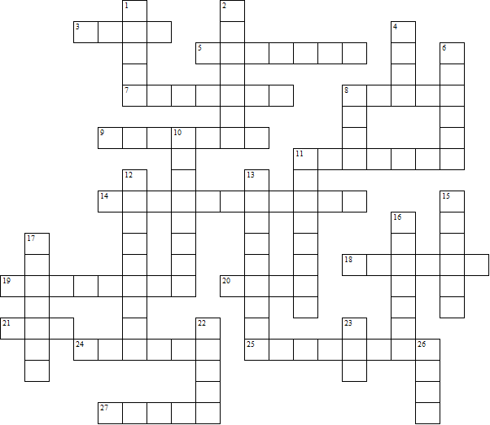

Across:  3 The sick and dying were taken away and .....  5 The soldiers wore ...... suits.  7 The town where the story takes place  8 Danny's surname  9 Cannibals  11 People hiding in underground shelters  14 The army headquarters (two words)  18 Danny's old PE teacher  19 Food and fuel were ..........  20 Danny fetched water each day from a .....  21 Danny's brother  24 Branwell's people called themselves .......  25 ......... took all their food away.  27 Danny had to ...... Ben to the farm. | Down:  1 People from other towns looking for food  2 The man killed by the 'badgers'  4 Everyone was given a ration .....  6 People had to stand in long ........ for food  8 The title: Brother in the .....  10 The 'spacers' were given .......... food.  11 The old farmer  12 People dying of radiation sickness  13 The author: Robert .......  15 The author: ...... Swindells  16 The title: ........ in the Land  17 People wandering around speaking to themselves  22 The storyteller  23 Danny's girlfriend  26 Danny's family had food because they had a .....
Brother in the Land

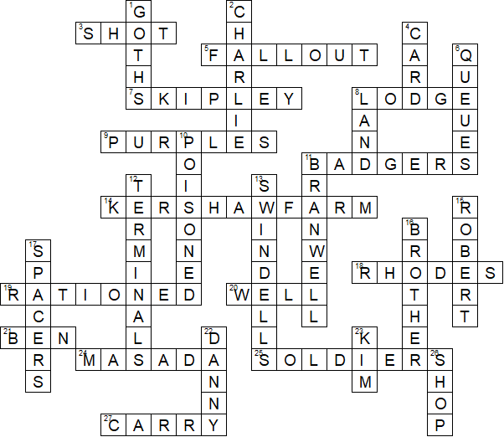

This puzzle was compiled using Toolbox.

For a free trial go to www.discoveryeducationalsoftware.co.uk/toolbox_e.htm

