Buddy

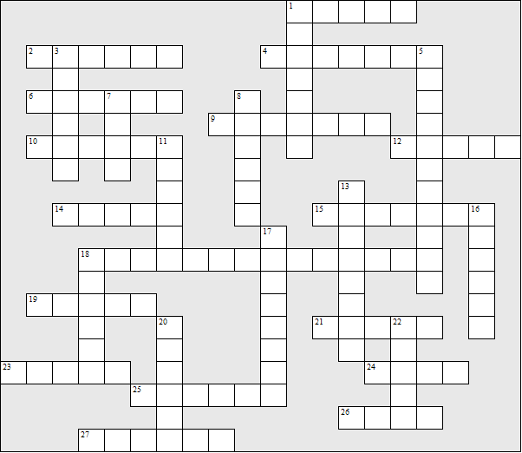

Across:  1 Buddy's mother's name  2 Buddy's dad got a job in a ........  4 Buddy had a ..... who died at birth  6 At the start Buddy's dad was in ........  9 Terry became the band's .......  10 Terry tried to form a band by putting ads in four  music .....  12 Buddy's father's name  14 The school band advertised for members on the  local .....  15 His father's accomplice: ... ......  18 The motor-bike was a .......-........  19 Des gave Terry ..... when he came out of prison.  21 His mum's friend  23 The two musicians Buddy met at school were .....  24 His dad's new girlfriend  25 Buddy's mum cut her hand on a broken ..... | 26 At one gig there was music playing on the ..... box  27 Terry bought himself a video ......  Down:  1 Terry went to live in a ..........  3 His mum's boss  5 Name of the second band  7 The first band practised in a .....  8 Buddy .... all his exams  11 His mum wanted him to stay on at .......  13 Buddy's dad liked to dress as a ....... ....  16 Buddy played the .......  17 Buddy recorded a ......... for his dad at Christmas.  18 The author: Nigel .......  20 Name of the first band: The .... .... Four  22 Buddy's surname

Buddy - Solution

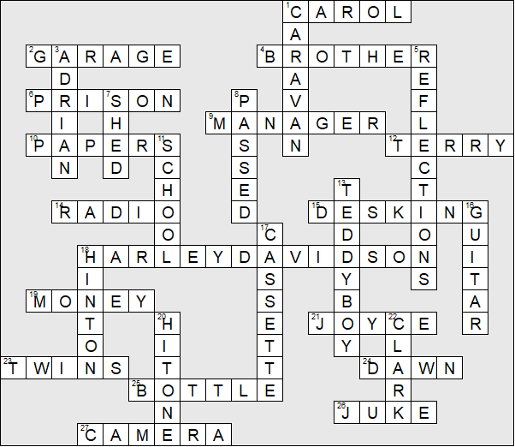

This puzzle was compiled in seconds using Toolbox.
For a free trial go to www.discoveryeducationalsoftware.co.uk

