What’s the capital of …..? (The Americas)

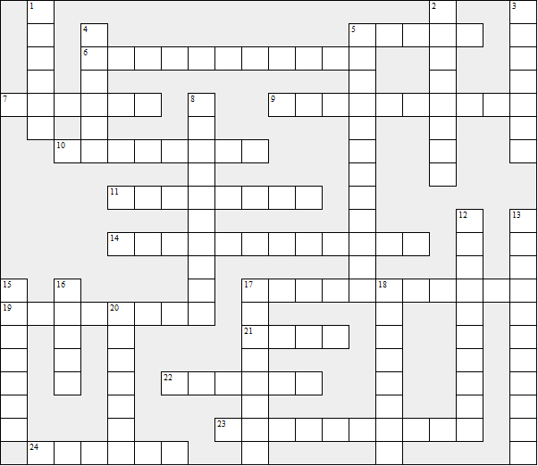

Across:  5 Bolivia  6 Honduras  7 Cuba  9 Uruguay  10 Saint Lucia  11 Jamaica  14 Haiti  17 Argentina  19 Paraguay  21 Peru  22 Colombia  23 USA  24 The Bahamas | Down:  1 Dominica  2 Brazil  3 Costa Rica  4 Canada  5 Dominican Republic  8 Barbados  12 Guyana  13 El Salvador  15 Nicaragua  16 Ecuador  17 Belize  18 Chile  20 Venezuela
What’s the capital of …..? (The Americas) – Solution

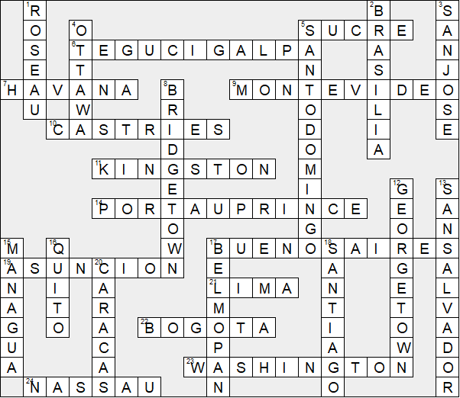

This worksheet was made up using TOOLBOX by Discovery Educational Software.

