What’s the capital of …..? (Asia)

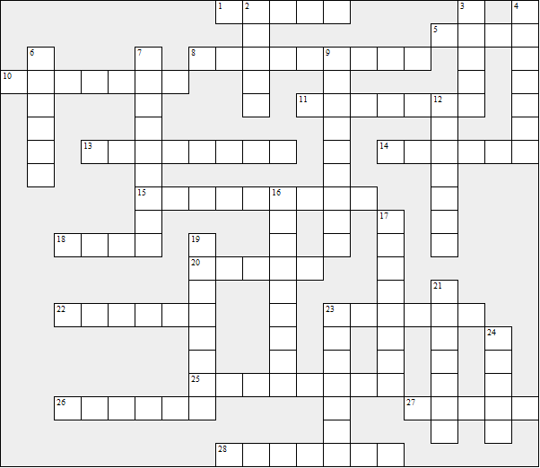

Across:  1 Bangladesh  5 Qatar  8 Cambodia  10 Armenia  11 Sri Lanka  13 Syria  14 Philippines  15 Myanmar  18 Azerbaijan  20 Jordan  22 Saudi Arabia  23 Iran  25 India  26 Oman  27 Afghanistan  28 China | Down:  2 Vietnam  3 Japan  4 Indonesia  6 Lebanon  7 Nepal  9 North Korea  12 Thailand  16 Pakistan  17 United Arab Emirates  19 Uzbekistan  21 Iraq  23 Georgia  24 South Korea
What’s the capital of …..? (Asia) – Solution

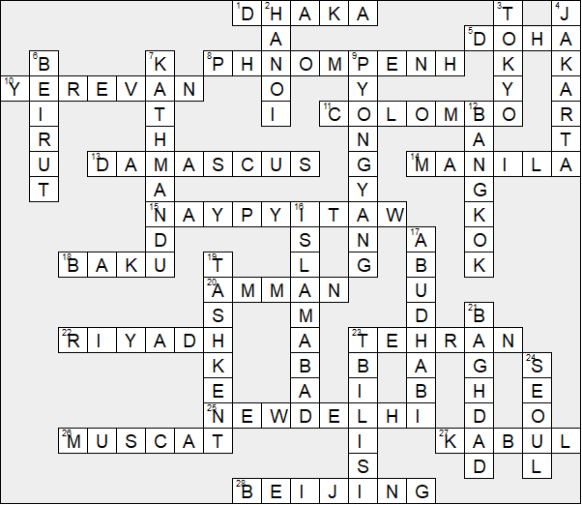

This worksheet was made up using TOOLBOX by Discovery Educational Software.

