What’s the capital of …..? (Europe)

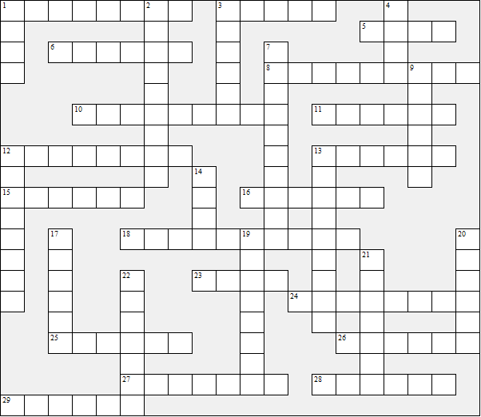

Across:  1 Hungary  3 France  5 Ukraine  6 Portugal  8 Iceland  10 Romania  11 Croatia  12 Belgium  13 Greece  15 UnitedKingdom  16 Poland  18 Denmark  23 Norway  24 Malta | 25 Ireland  26 Albania  27 Cyprus  28 Russia  29 Germany | Down:  1 Switzerland  2 Sweden  3 Czechia  4 Latvia  7 Slovakia  9 Austria  12 Serbia  13 Netherlands  14 Italy  17 Spain  19 Finland  20 Turkey  21 Lithuania  22 Estonia
What’s the capital of …..? (Europe) – Solution

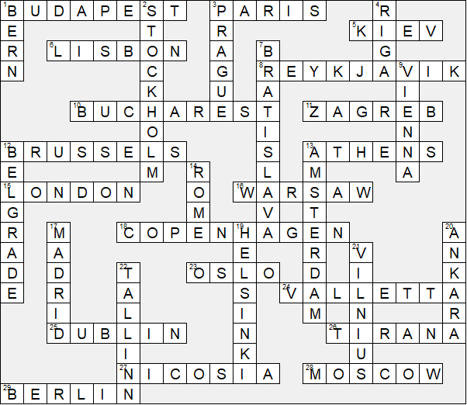

This worksheet was made up using TOOLBOX by Discovery Educational Software.

