Cardiff Castle

Start at the top left-hand corner. Follow the line of letters and try to make sense of it.

Write it out correctly, putting in capital letters, punctuation and spaces.

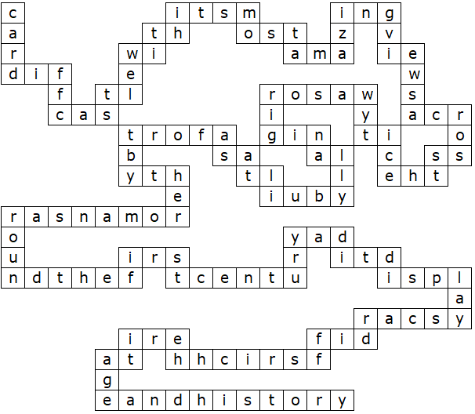
Cardiff Castle (Solution)

Cardiff Castle, with its most amazing views across the city, was originally built as a fort by the Romans around the first century A.D. It displays Cardiff's rich heritage and history.

This puzzle was compiled in seconds using Toolbox.
For a free trial go to www.discoveryeducationalsoftware.co.uk/toolbox_e.htm

