Cars

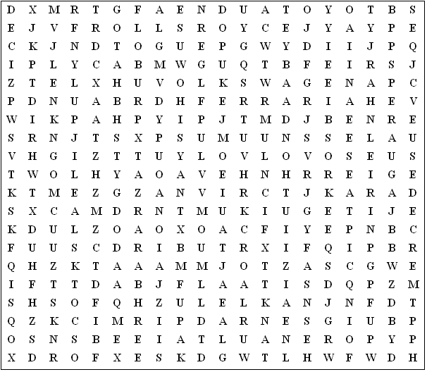

Aston Martin Lamborghini Volkswagen Audi

Alfa Romeo Vauxhall Mercedes Chrysler Ford

Daihatsu Ferrari Renault Jaguar Peugot

Citroen Daimler Hyundai Nissan Toyota

Totota Volvo Honda Mazda Skoda

Saab Fiat Seat BMW Rolls Royce
Cars - Solution

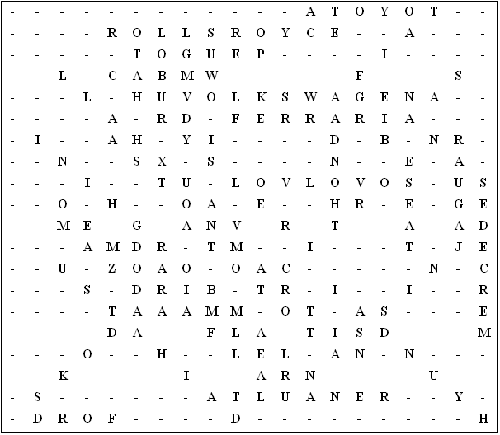

This puzzle was compiled in seconds using Toolbox.
For a free trial go to www.discoveryeducationalsoftware.co.uk/toolbox_e.htm

