CAT ON A HOT TIN ROOF
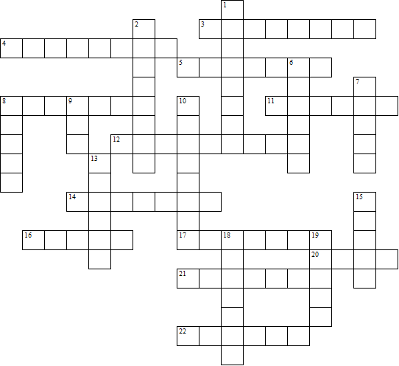

Across:  3 The father (two words)  4 Today is 3 across's what?  5 The family surname  8 The mother (two words)  11 What the plantation grows  12 and 1 down: The author  14 16 across broke his ankle jumping  over .......  16 The son who is an alcoholic  17 Lacey's occupation  20 See 18 down  21 16 across 's close friend who died  22 Brother man | Down:  1 See 12 across  2 Who is the cat on a hot tin roof?  6 The preacher's surname  7 3 across thinks he has a spastic  ........  8 The doctor's surname  9 Sister woman  10 Margaret calls the children 'no-  neck ........'  13 16 across walks with the help of a  .......  15 The aunt who telephones  18 and 20 across: The place where alcoholics are treated  19 The number of acts in the play
CAT ON A HOT TIN ROOF – Solution

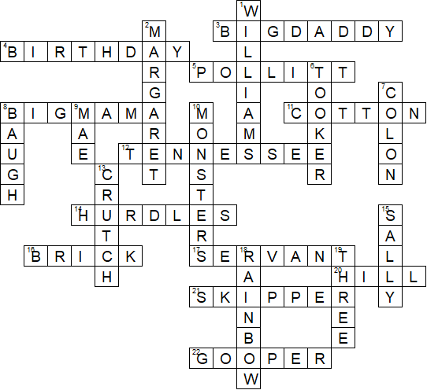

This worksheet was made up using TOOLBOX by Discovery Educational Software.

