Chemical Elements

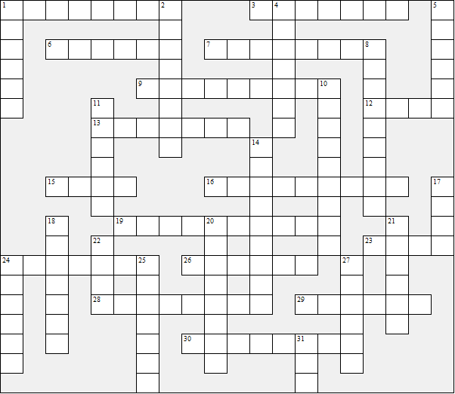

Across:  1 H  3 S  6 Co  7 Ti  9 K  12 Ne  13 As  15 Fe  16 Al | 19 P  23 Au  24 Ca  26 Ba  28 Cr  29 Ra  30 W | Down:  1 He  2 N  4 U  5 O  8 Mg  10 Mn  11 C  14 Pu  17 Pb | 18 Si  20 Pt  21 Na  22 Zn  24 Cu  25 Hg  27 I  31 Sn

Chemical Elements - Solution

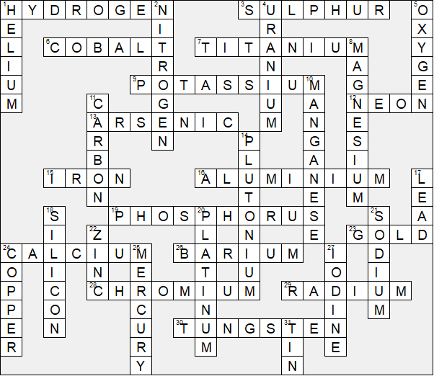

This worksheet was made up using TOOLBOX by Discovery Educational Software.

