Christmas

Beginning with the letter in the square box, follow a continuous path to find the words listed below. The trail passes through each and every letter once and may twist up, down or sideways, but never diagonally.

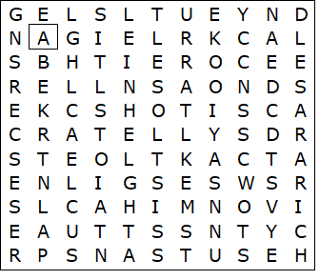

angel  bells  cake  candles  cards  chestnuts  crackers  decorations  holly  ivy | lights  mistletoe  presents  santa claus  sleigh  snow  star  tinsel  turkey

Christmas - Solution

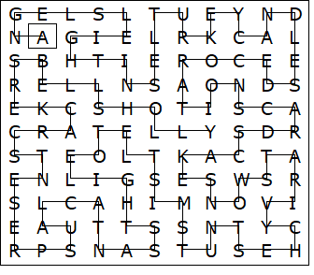

This worksheet was made up using TOOLBOX by Discovery Educational Software.

