Find all the words below the tree. Then, reading from the top, left to right, take each unused letter to make a hidden message.

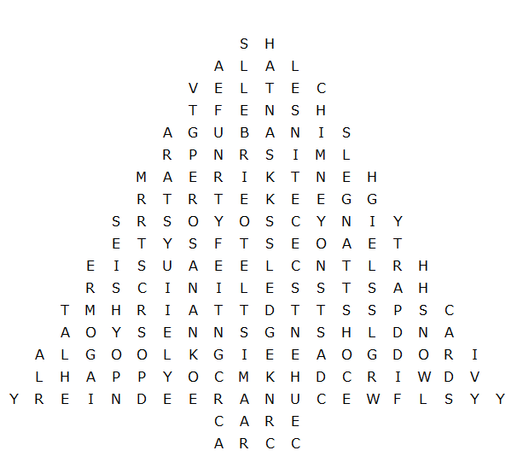

chestnuts mistletoe presents reindeer stocking fun

ivy crackers tree cake snow star toys

Rudolph candles chimney angels carols sledge sleigh

tinsel turkey lights bells fairy holly cards party

Santa icing happy frost
Solution:

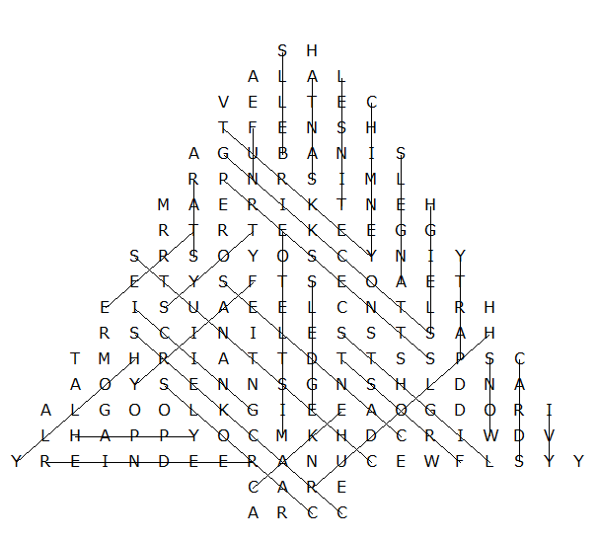

Hidden message:

HAVE A MERRY CHRISTMAS AND A GOOD NEW YEAR

This puzzle was compiled in seconds using Toolbox.
For a free trial go to www.discoveryeducationalsoftware.co.uk/toolbox_e.htm

