Cinderella Maze

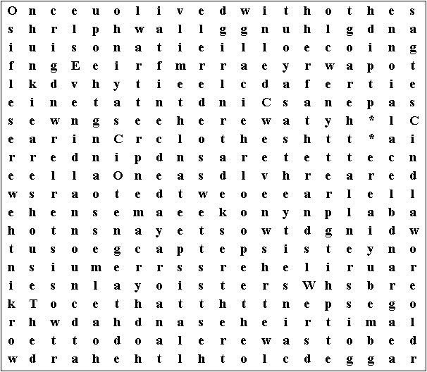

Starting at the top left-hand corner, draw a line as you follow this story:

Once upon a time there was a young girl called Cinderella, who lived with her father and two stepsisters.

While her stepsisters spent their time buying pretty new clothes and going to parties, Cinderella wore old, ragged clothes and had to do all the hard work in the house.

The two sisters were selfish, unkind girls. Even wearing their fine clothes, they never looked as sweet and pretty as Cinderella.

One day a royal messenger came to announce that there was to be a grand ball at the palace.

This puzzle was compiled in seconds using Toolbox.
For a free trial go to www.discoveryeducationalsoftware.co.uk/toolbox_e.htm

