Clothes

Beginning with the letter in the square box, follow a continuous path to find the words listed below. The trail passes through each and every letter once and may twist up, down or sideways, but never diagonally.

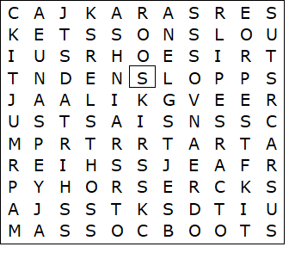

ANORAK  BOOTS  DRESS  GLOVES  JACKET  JEANS  JUMPER  PYJAMAS  SANDALS  SCARF | SHIRT  SHOES  SHORTS  SKIRT  SLIPPERS  SOCKS  SUIT  TRACKSUIT  TRAINERS  TROUSERS

Clothes – Solution

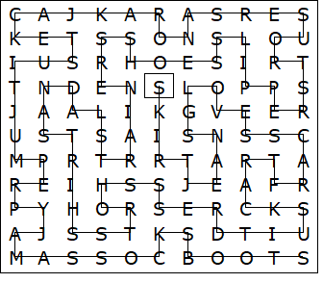

This worksheet was made up using TOOLBOX by Discovery Educational Software.

