Clothes

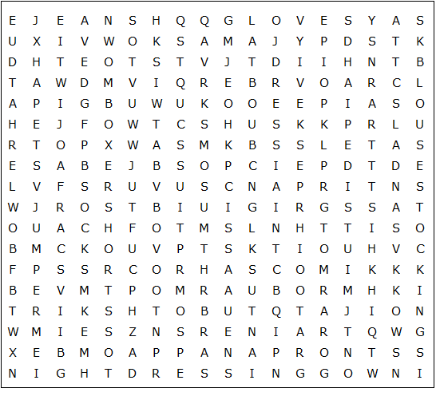

swimming costume dressing gown boxer shorts nightdress miniskirt

bowler hat tracksuit stockings trousers trainers slippers bra

sandals pyjamas shorts jumper hoodie blouse top hat tie

jacket gloves anorak tights jeans shirt dress coat top

skirt socks shoes boots pants apron scarf suit cap

Clothes – Solution

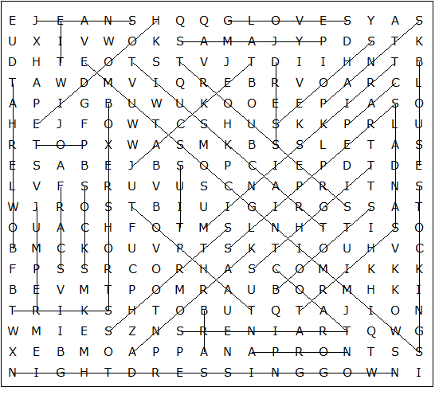

This worksheet was made up using TOOLBOX by Discovery Educational Software.

