Computer

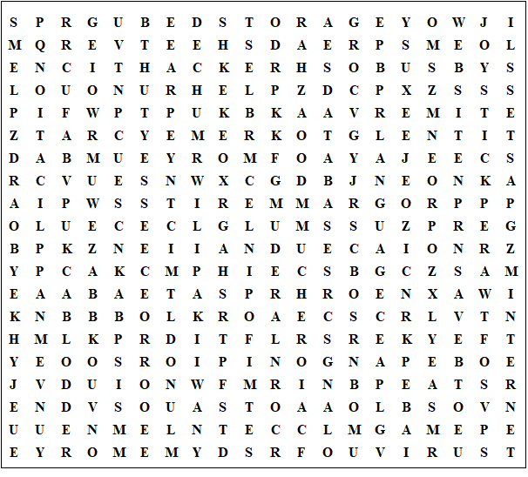

Search engine spreadsheet application programmer mainframe processor disk drive computer keyboard database internet software joystick graphics language monitor compile network storage scanner printer website browser screen backup memory hacker floppy laptop socket mouse email cable paste debug virus sound save open file surf copy undo help game bus

Computer

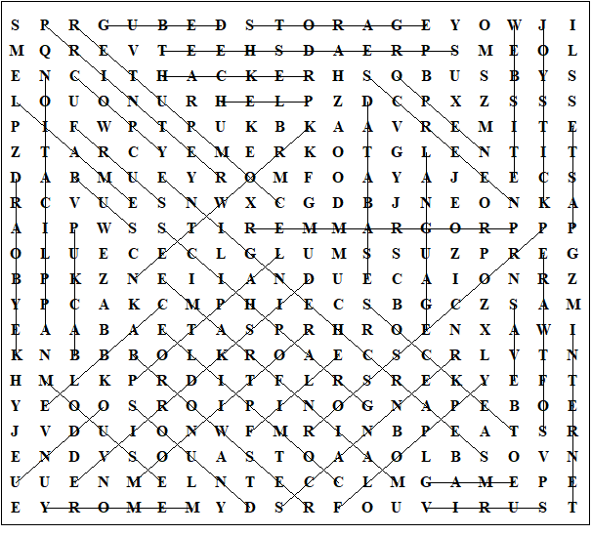

This worksheet was made up using TOOLBOX by Discovery Educational Software.

For a free trial go to www.discoveryeducationalsoftware.co.uk/toolbox_e.htm

