Dog breeds

Beginning with the letter in the square box, follow a continuous path to find the words listed below. The trail passes through each and every letter once and may twist up, down or sideways, but never diagonally.

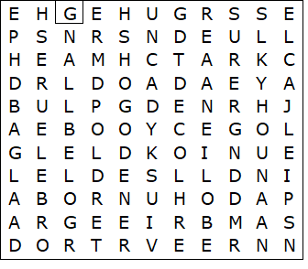

BEAGLE  BULLDOG  COLLIE  DACHSHUND  DOBERMANN  GERMAN SHEPHERD  GOLDEN RETREIVER | GREAT DANE  GREYHOUND  HUSKY  JACK RUSSELL  LABRADOR  POODLE  SPANIEL

Dog breeds – Solution

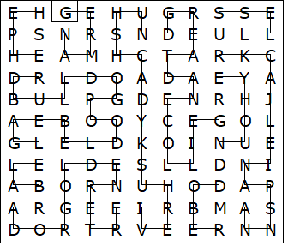

This worksheet was made up using TOOLBOX by Discovery Educational Software.

