The Edinburgh Festival

Start at the top left-hand corner. Follow the line of letters and try to make sense of it.

Write it out correctly, putting in capital letters, punctuation and spaces.

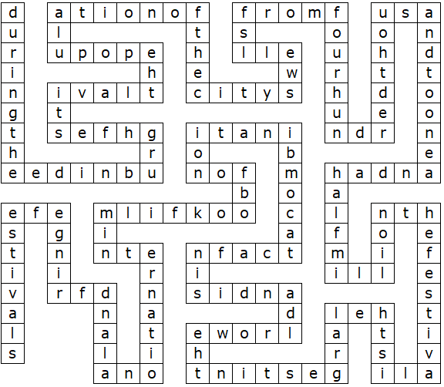
The Edinburgh Festival (Solution)

During the Edinburgh Festival the population of the city swells from four hundred thousand to one and a half million. The festival is the largest in the world and is in fact a combination of book, film, international and fringe festivals.

This puzzle was compiled in seconds using Toolbox.
For a free trial go to www.discoveryeducationalsoftware.co.uk/toolbox_e.htm

