Europe

1 Find the 25 European countries hidden in the puzzle

2 Going from left to right, starting with the top row, write down all the letters which have not been used, to find eight more countries.

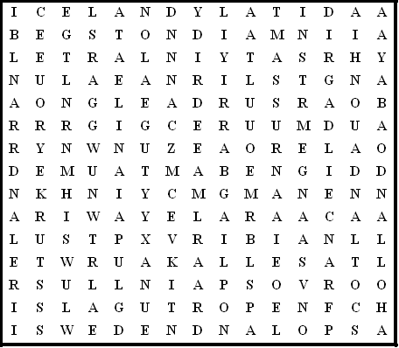

Switzerland Luxembourg Portugal Scotland Bulgaria

Holland Belgium Iceland Albania Denmark Germany

Ireland Hungary France Greece Cyprus Russia Poland

Austria Norway Sweden Turkey Italy Spain England

1 ………………………………………………… 5 …………………………………………………
2 ………………………………………………… 6 …………………………………………………
3 ………………………………………………… 7 …………………………………………………
4 ………………………………………………… 8 …………………………………………………
Europe - solution

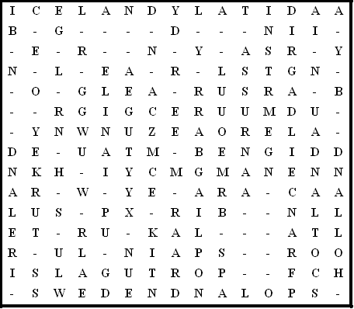

- Estonia
- Malta
- Lithuania
- Andorra
- Romania
- Latvia
- Wales
- Slovenia

This puzzle was compiled in seconds using Toolbox.
For a free trial go to www.discoveryeducationalsoftware.co.uk/toolbox_e.htm

