Farm animals

Beginning with the letter in the square box, follow a continuous path to find the words listed below. The trail passes through each and every letter once and may twist up, down or sideways, but never diagonally.

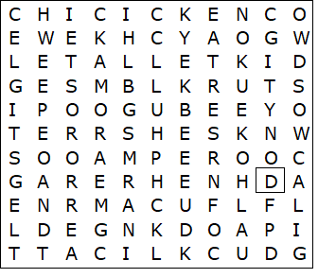

bull  calf  cattle  chick  chicken  cow  donkey  duck  duckling  ewe  foal  gander  goat | goose  hen  horse  kid  lamb  mare  pig  piglet  ram  rooster  sheep  sow  turkey

Farm animals – Solution

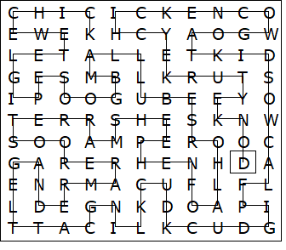

This worksheet was made up using TOOLBOX by Discovery Educational Software.

