Flowers

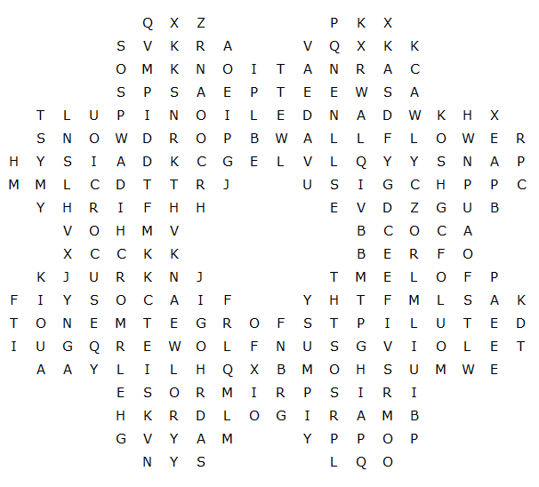

Forget-me-not wallflower carnation buttercup lily
dandelion sunflower snowdrop daffodil primrose
marigold bluebell sweetpea crocus violet orchid
tulip poppy daisy pansy lupin rose iris

Flowers – solution



