Fruit

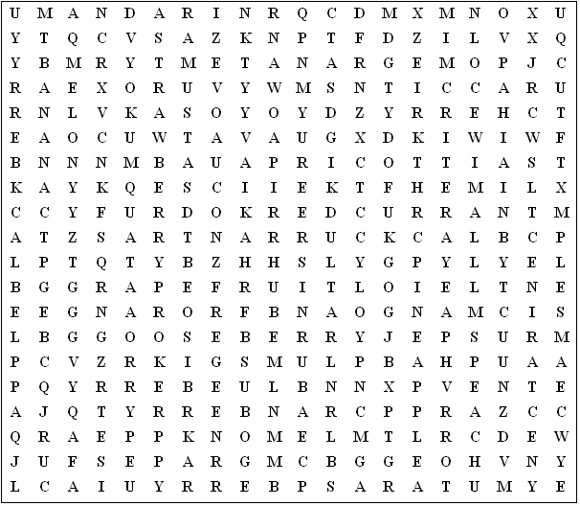

blackcurrant pomegranate grapefruit blackberry redcurrant kiwi

strawberry gooseberry pineapple blueberry raspberry cranberry

nectarine mandarin apricot kumquat satsuma banana cherry

orange grapes apple peach lemon melon mango guava

plum pear lime
Fruit (Solution)

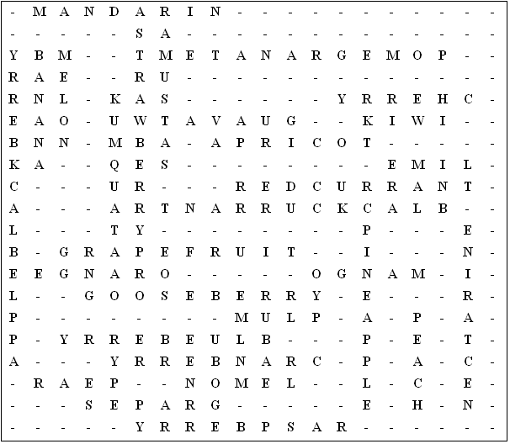

This puzzle was compiled in seconds using Toolbox.
For a free trial go to www.discoveryeducationalsoftware.co.uk/toolbox_e.htm

