Furniture

Beginning with the letter in the square box, follow a continuous path to find the words listed below. The trail passes through each and every letter once and may twist up, down or sideways, but never diagonally.

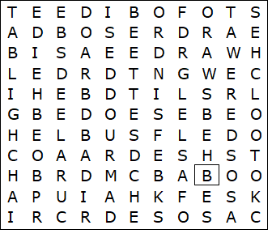

ARMCHAIR  BED SETTEE  BEDSIDE TABLE  BOOKCASE  CHEST OF DRAWERS  CUPBOARD  DESK  DOUBLE BED | HIGHCHAIR  SHELF  SIDEBOARD  SINGLE BED  SOFA  STOOL  WARDROBE

Furniture – Solution

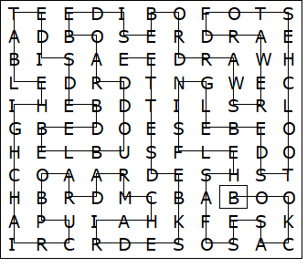

This worksheet was made up using TOOLBOX by Discovery Educational Software.

