Halloween

Find the hidden words, then find a sectret message hidden in the unused letters.
Start top left and work your way down going from left to right.

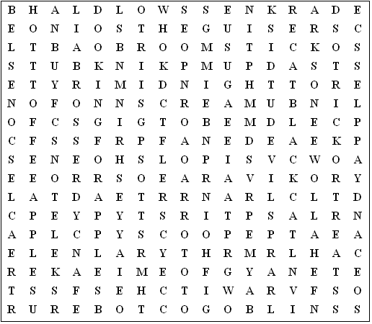

Words:

bobbing for apples dooking for apples treacle scones turnip lantern

trick-or-treat toffee apples costume party candy apples broomstick

fancy dress Halloween skeletons black cat midnight vampires

darkness October guisers goblins witches pumpkin ghosts

devils horror scream
Halloween - Solution

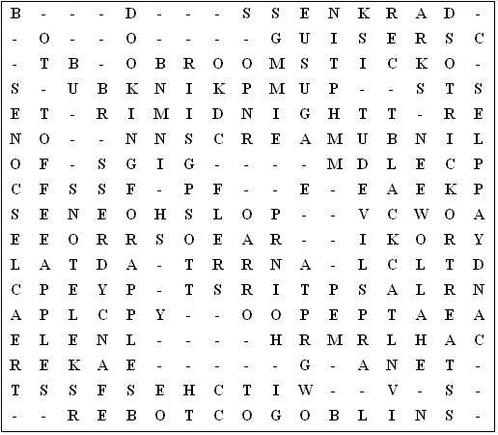

Halloween is the last day of October and is a very scary time of year for us.

This puzzle was compiled in seconds using Toolbox.
For a free trial go to www.discoveryeducationalsoftware.co.uk/toolbox_e.htm

