Hugh Grant films

Find twenty Hugh Grant films hidden in this puzzle.

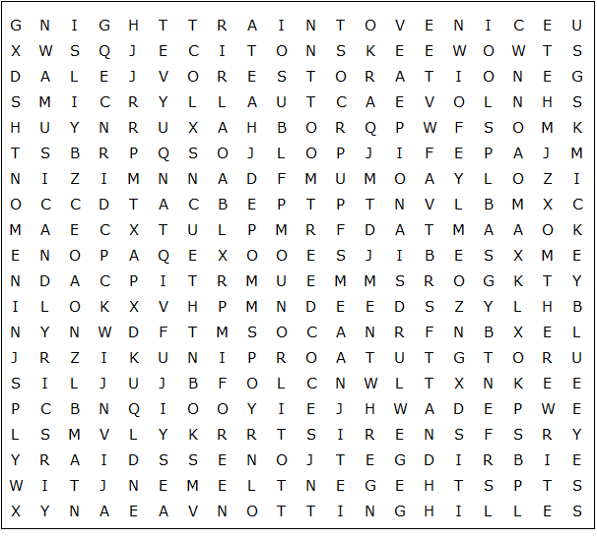

Hugh Grant films – Solution

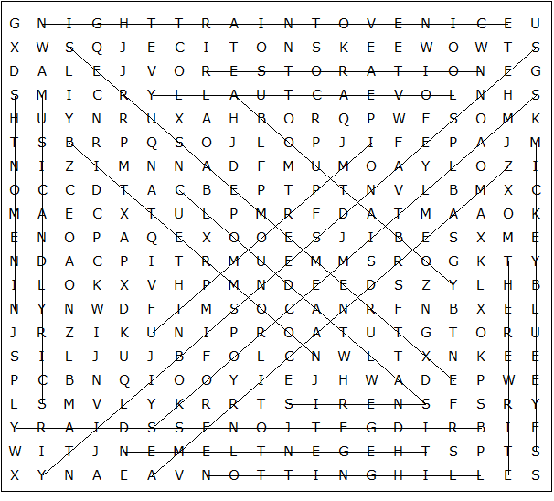

About a Boy  American Dreamz  Bitter Moon  Bridget Jones's Diary  Cloud Atlas  Extreme Measures  Impromptu  Love Actually  Mickey Blue Eyes  Music and Lyrics | Night Train to Venice  Nine Months  Notting Hill  Restoration  Sense and Sensibility  Sirens  Small Time Crooks  The Gentlemen  The Rewrite  Two Weeks Notice

This worksheet was made up using TOOLBOX by Discovery Educational Software.

