Islands of the world

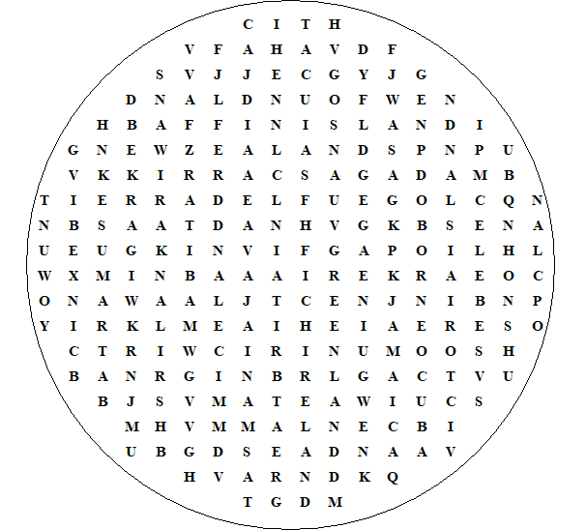

Victoria Island Tierra del Fuego GreatBritain Baffin Island Newfoundland Madagascar New Zealand New Guinea Greenland Sri Lanka Tasmania Iceland Ireland Sumarta Jamaica Celebes Borneo Honshu Java Cuba

Islands of the world

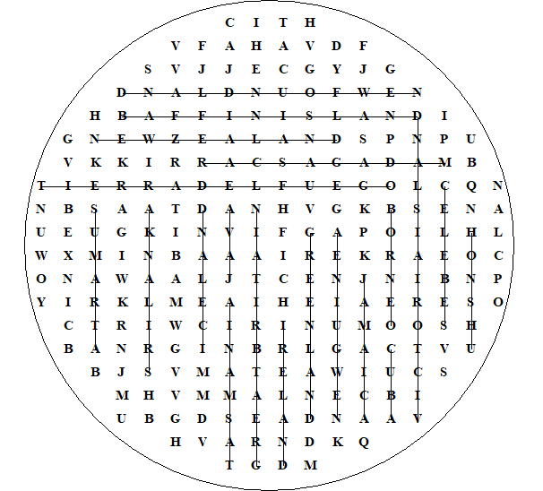

This worksheet was made up using TOOLBOX by Discovery Educational Software.

For a free trial go to www.discoveryeducationalsoftware.co.uk/toolbox_e.htm

