Joseph and the Amazing Technicolor Dreamcoat

1 Find the 26 colours hidden in the puzzle

2 Going from left to right, starting with the top row, write down all the letters which have not been used, to find three more colours.

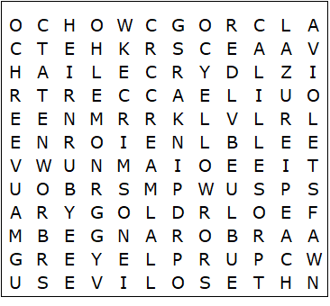

brown  black  crimson  fawn  gold  green  grey  purple  lemon  lilac  mauve  cream  ochre | olive  orange  blue  peach  ruby  pink  red  rose  azure  silver  violet  white  yellow

Joseph’s Amazing Technicolor Dreamcoat– Solution

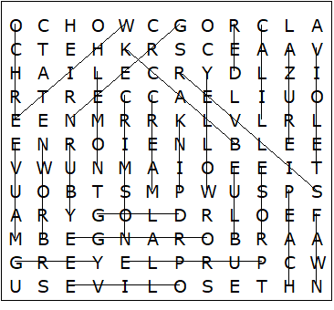

The additional colours are: chocolate, scarlet and russet

This worksheet was made up using TOOLBOX by Discovery Educational Software.

