How well do you know Britain?

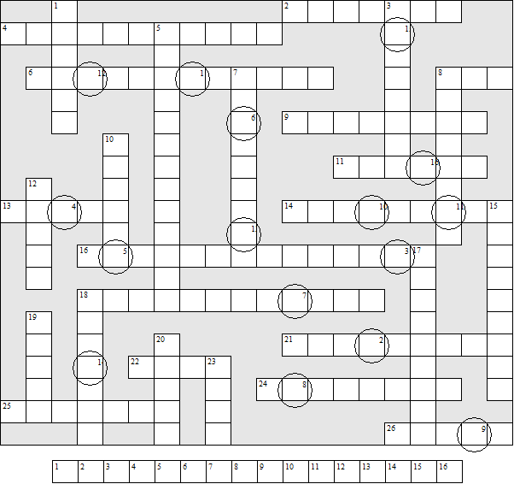

Across:  2 A London football team  4 Most famous playwright  6 The area represented by an MP  8 The state television channel  9 The most westerly point of English mainland  11 London stands on the river .....  13 Unit of currency  14 Large county in northern England  16 The water between England and France  18 Right-wing political party  21 Prince William's wife  22 South-eastern county  24 One of London's airports  25 Capital of Northern Ireland  26 Glasgow's river | Down:  1 Left-wing political party  3 The water between Britain and Holland  5 The king  7 Capital of Scotland  8 Highest mountain in Britain  10 Capital of England  12 A channel port  15 The former queen  17 City on the Mersey  18 Capital of Wales  19 There are 100 of them in a pound  20 City on the Tay  23 River at Newcastle

How well do you know Britain? (Answer sheet)

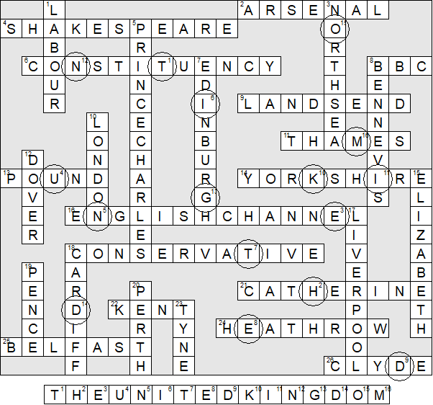

This puzzle was compiled in seconds using Toolbox, yours for onky £10.
For a free trial go to www.discoveryeducationalsoftware.co.uk/toolbox_e.htm

