Lakes of the World

Beginning with the letter in the square box, follow a continuous path to find the words listed below. The trail passes through each and every letter once and may twist up, down or sideways, but never diagonally.

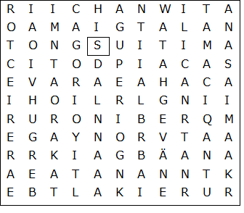

Albert  Baikal  Erie  Great Bear  Huron  Ladoga  Malawi  Michigan  Ontario | Qinghai  Saimaa  Superior  Tana  Tanganyika  Titicaca  Turkana  Vänern  Victoria

Lakes of the World – Solution

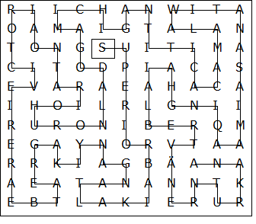

This worksheet was made up using TOOLBOX by Discovery Educational Software.

