Metals

Beginning with the letter in the square box, follow a continuous path to find the words listed below. The trail passes through each and every letter once and may twist up, down or sideways, but never diagonally.

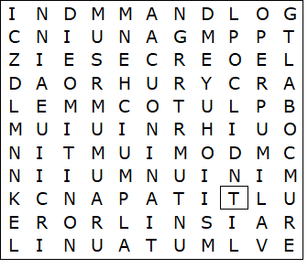

Aluminium  Chromium  Cobalt  Copper  Gold  Indium  Iron  Lead  Manganese  Mercury | Nickel  Platinum  Plutonium  Rhodium  Silver  Tin  Titanium  Uranium  Zinc

Metals – Solution

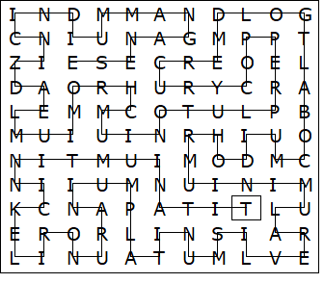

This worksheet was made up using TOOLBOX by Discovery Educational Software.

