Metals

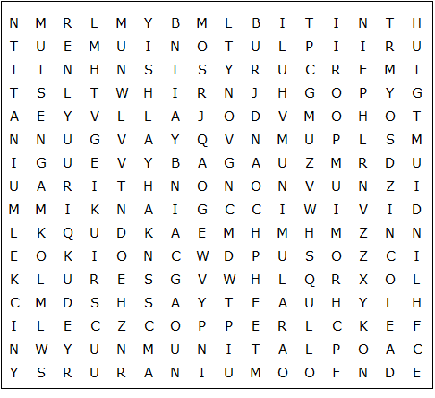

Vanadium Nickel Copper Gold Lead Iron Zinc Tin

Chromium Platinum Mercury Uranium Indium Silver Cobalt

Magnesium Manganese Plutonium Aluminum Titanium

Metals – Solution

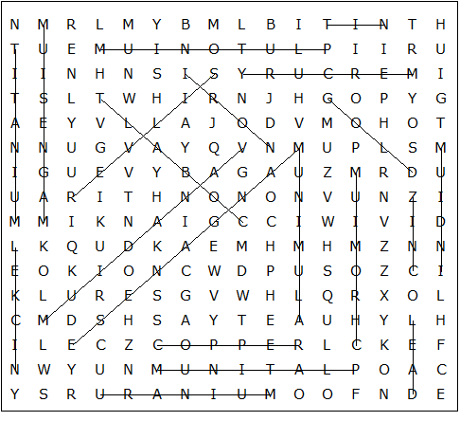

This worksheet was made up using TOOLBOX by Discovery Educational Software.

