OF MICE AND MEN
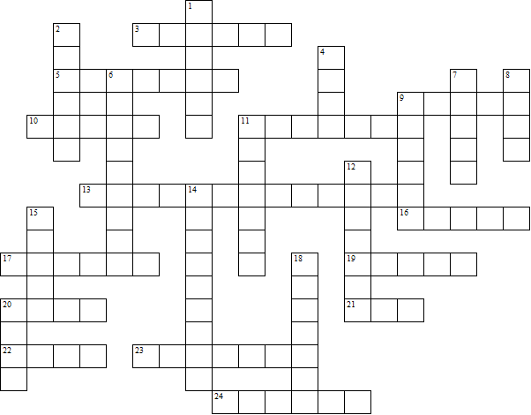

Across:  3 George tells people Lennie is not very .......  5 The animals Lennie wants to tend one day  9 Lennie's aunt  10 What they have for supper the first night  11 The word used for 'cleaner'  13 The author  16 Lennie's surname  17 The man who picks a fight with Lennie  19 George and Lennie plan to save up and buy  a ...........  20 The place where they were working before  21 Lennie's pet that dies  22 The number of pups [4 down] drowned  23 The man who shoots the old dog  24 George tells the boss Lennie is his ........... | Down:  1 George's surname  2 The boss's son  4 The man who has the pups  6 The workers sleep in a ...........  7 The old man with only one hand  8 Lennie tells George he could go  away and live in a ........  9 The black stable buck’s name  11 The nearby town  12 What Lennie likes with his food  14 The card game George plays on  his own  15 The first night Lennie had a  dead ........ in his pocket  18 The river  20 Lennie kills Curley's ..........
OF MICE AND MEN – Solution

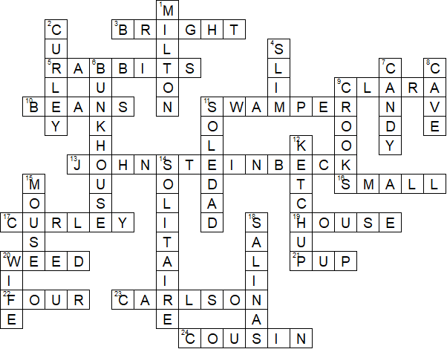

This worksheet was made up using TOOLBOX by Discovery Educational Software.

